**TUGAS PERCOBAAN 2**

**PENGOLAHAN CITRA**

**MK401**



**Disusun oleh :**

**Ricky Silitonga (4211901034)**

**PROGRAM STUDI TEKNIK MEKATRONIKA**

**JURUSAN TEKNIK ELEKTRO**

**POLITEKNIK NEGERI BATAM**

**2020**

**MEMBACA DAN MENGOLAH FILE CITRA**

Tugas dan Pertanyaan

1. Tambahkan koding pada button FlipVertical

private void button6_Click(object sender, EventArgs e)

{

imageFlipping = 2; // flip vartical ( vertical == 2)

setImageFlipping(imageFlipping);

}

1. Tambahkan koding pada button Rotate Right 180 dan tombol Rotate Right 270

private void button8_Click(object sender, EventArgs e)

{

imageRotation = 180; // rotasi 180 deg

setImageRotation(imageRotation);

}

private void button9_Click(object sender, EventArgs e)

{

imageRotation = 270; // rotasi 270 deg

setImageRotation(imageRotation);

}

1. Tambahkan koding pada button dan trackBar yTrans

private void trackBar2_Scroll(object sender, EventArgs e)

{

if (tempImage == null) return;

int xTrans = trackBar1.Value;

int yTrans = trackBar2.Value;

setTranslation(xTrans, yTrans);

// menampilkan nilai translasi pada textbox

textBox3.Text = string.Format("{0}", trackBar1.Value);

textBox4.Text = string.Format("{0}", trackBar2.Value);

}

1. Tambahkan koding untuk masing-masing radio button pada image flipping dan image rotation.

// flipping radio button

private void radioButton1_CheckedChanged(object sender, EventArgs e)

{

imageFlipping = 1;

setImageFlipping(imageFlipping);

}

private void radioButton2_CheckedChanged(object sender, EventArgs e)

{

imageFlipping = 2;

setImageFlipping(imageFlipping);

}

// rotation radio button

private void radioButton3_CheckedChanged(object sender, EventArgs e)

{

imageRotation = 90;

setImageRotation(imageRotation);

}

private void radioButton4_CheckedChanged(object sender, EventArgs e)

{

imageRotation = 180;

setImageRotation(imageRotation);

}

private void radioButton5_CheckedChanged(object sender, EventArgs e)

{

imageRotation = 270;

setImageRotation(imageRotation);

}

1. Laporan merupakan hasil screenshoot/save hasil running program

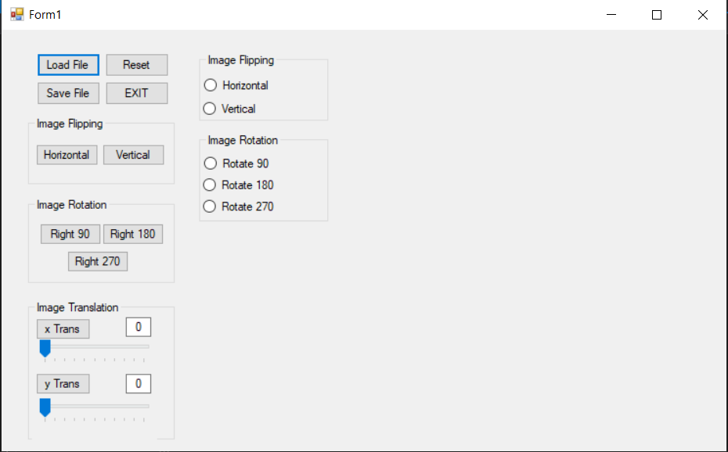

Tampilan awal

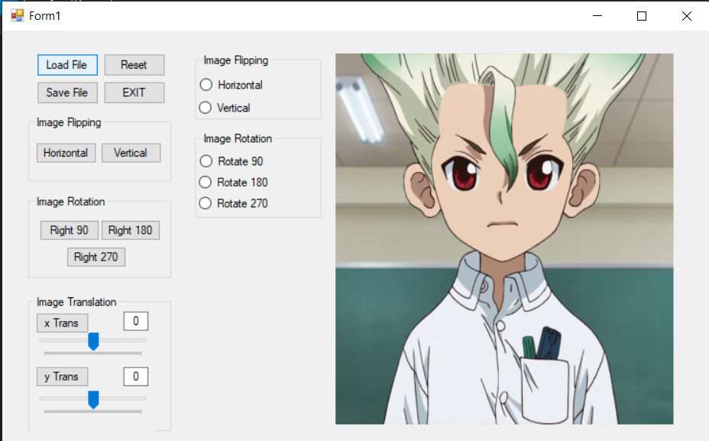

File citra di load

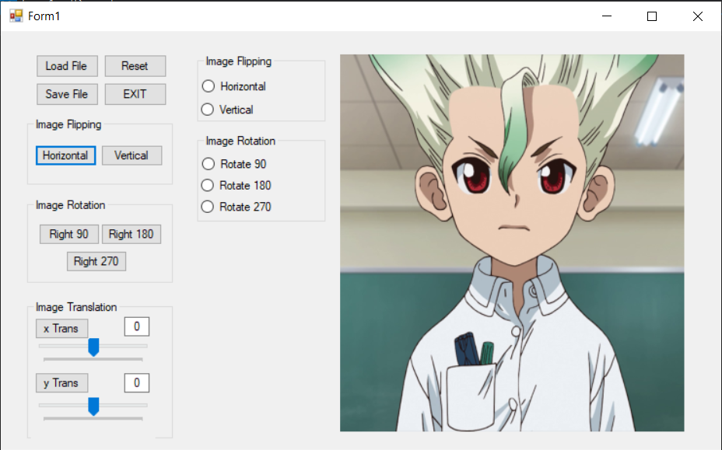

Flip horizontal dengan button

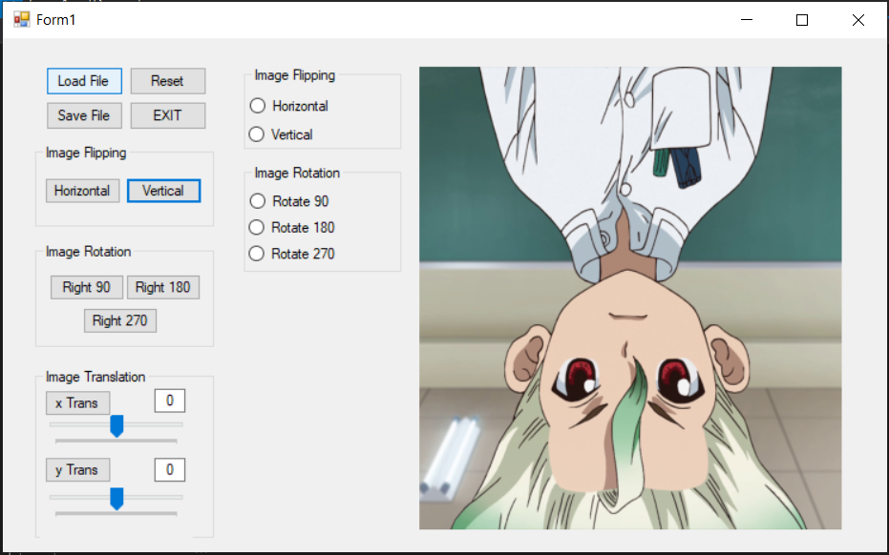

Flip vertical dengan button

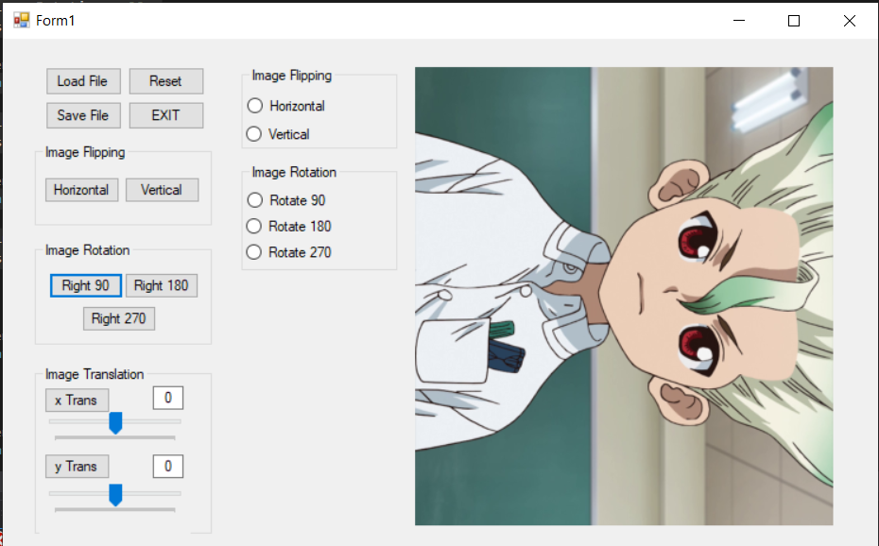

Rotate 90 derajat dengan button

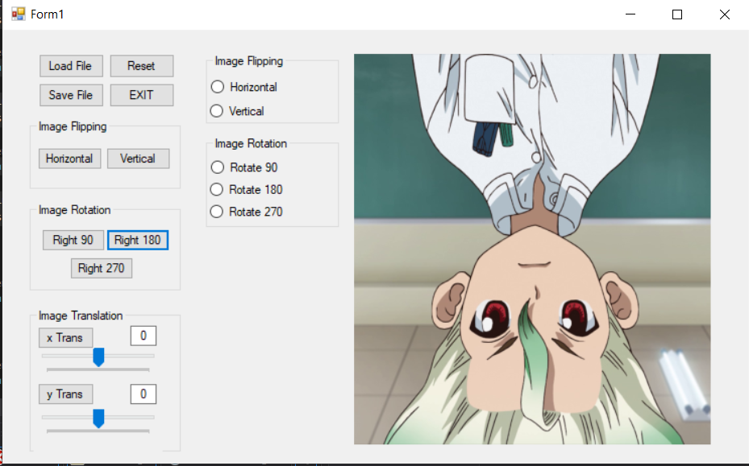

Rotate 180 derajat dengan button

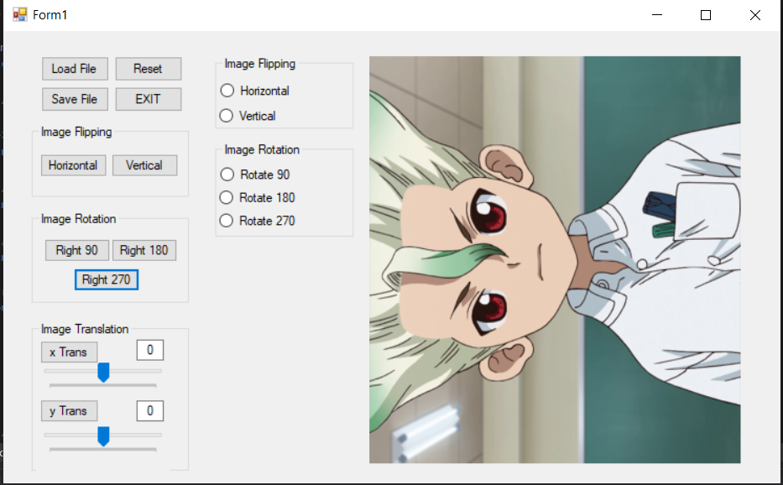

Rotate 270 derajat dengan button

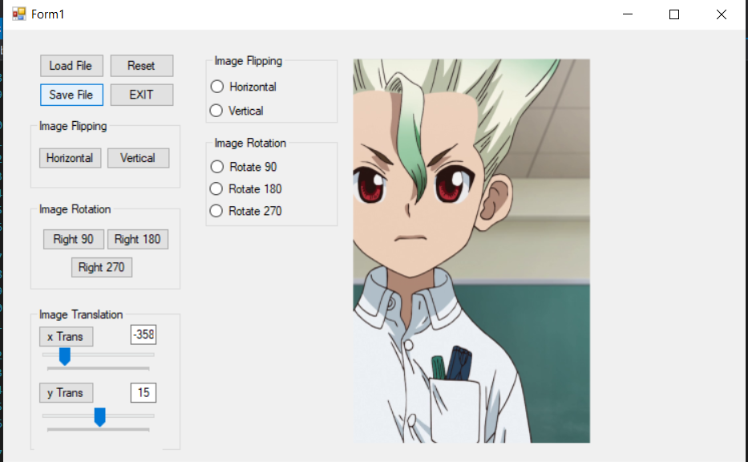

Translation dengan trackbar

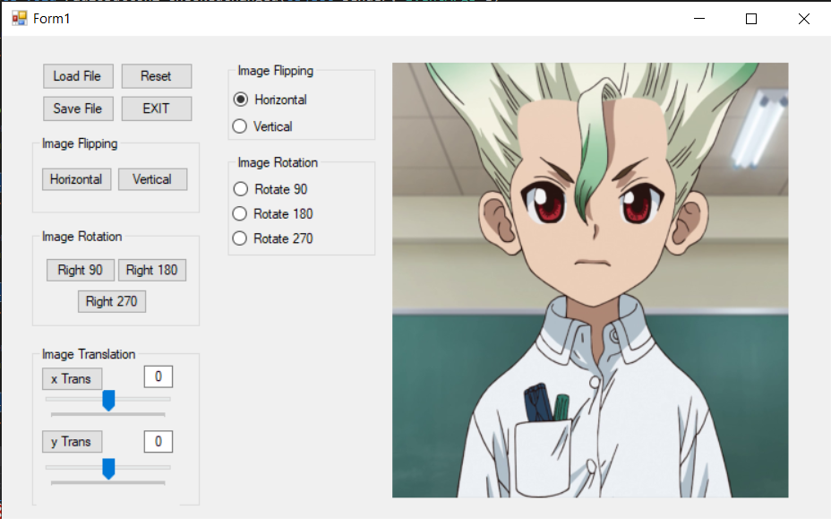

Flip horizontal dengan radio button

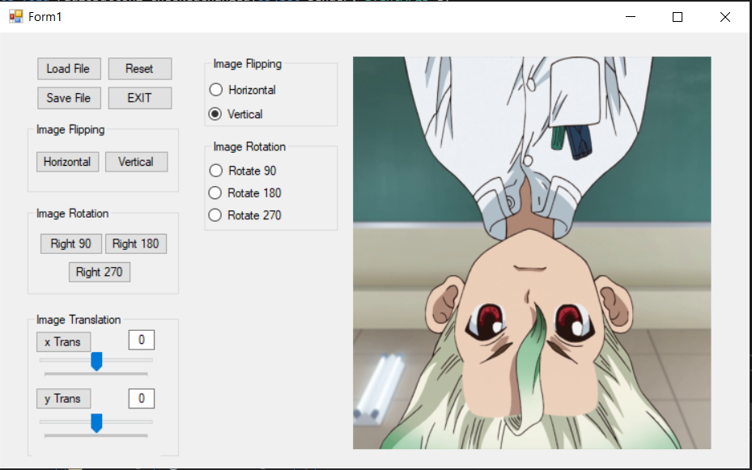

Flip vertical dengan radio button

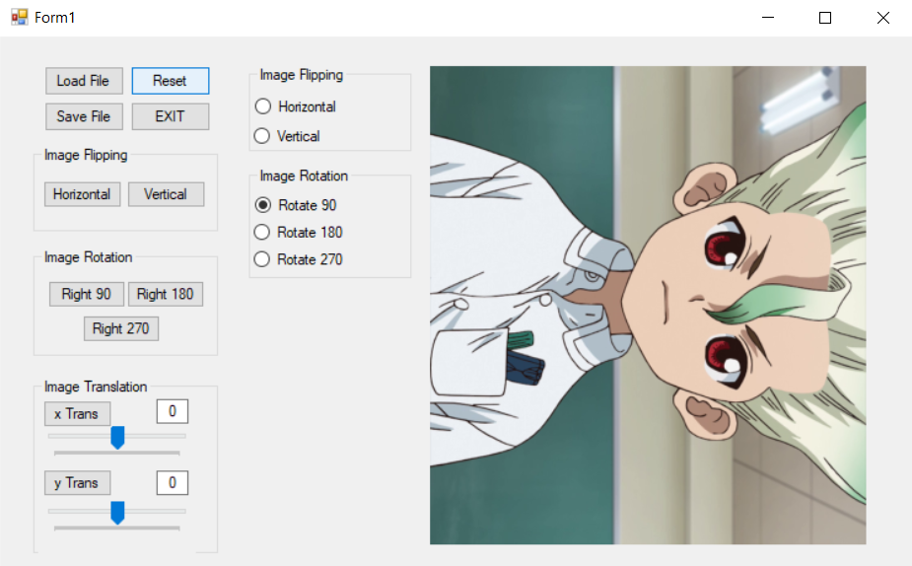

Rotate 90 derajat dengan radio button

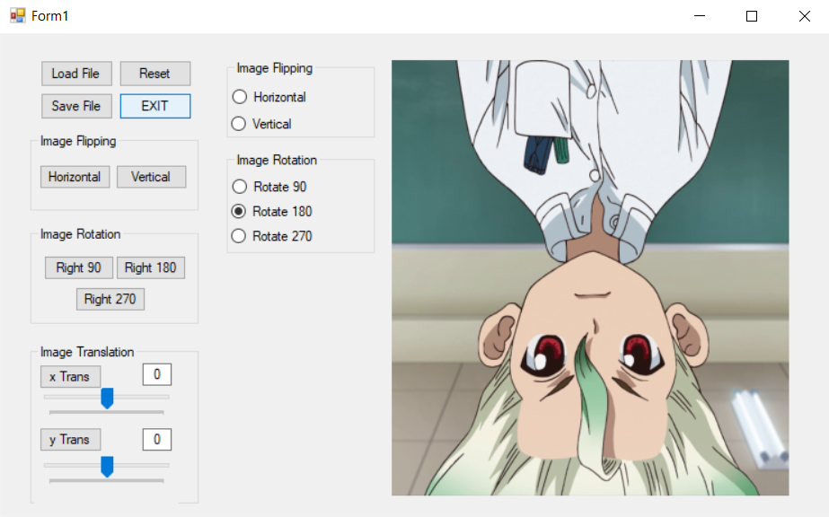

Rotate 180 derajat dengan radio

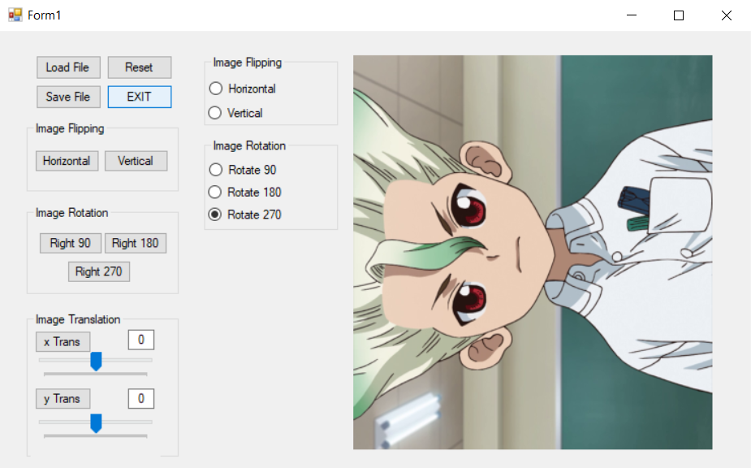

Rotate 270 derajat dengan radio

**Source Code**

using System;

using System.Collections.Generic;

using System.ComponentModel;

using System.Data;

using System.Drawing;

using System.Linq;

using System.Text;

using System.Threading.Tasks;

using System.Windows.Forms;

using System.Drawing.Imaging;

using System.IO;

namespace Percobaan_2

{

public partial class Form1 : Form

{

// global variable

Bitmap sourceImage, tempImage;

int imageHeight, imageWidth;

// image flipping

int imageFlipping;

// image rotation

int imageRotation;

public Form1()

{

InitializeComponent();

trackbarInitialization();

textBoxInitialization();

}

// my function

private void trackbarInitialization()

{

// trackbar init

trackBar1.Value = 0;

trackBar2.Value = 0;

}

private void textBoxInitialization()

{

textBox3.Text = "0";

textBox4.Text = "0";

}

// flip

private void setImageFlipping(int flipping)

{

if (tempImage == null) return;

Bitmap flipImage = new Bitmap(tempImage);

/* Image flipping

1. Horizontal

2. Vertical

*/

for(int x=0; x<imageWidth; x++)

{

for(int y=0; y<imageHeight; y++)

{

Color w = flipImage.GetPixel(x, y);

if(flipping == 1)

{

tempImage.SetPixel(imageWidth - 1 - x, y, w); // flip horizontal

}

else if(flipping == 2)

{

tempImage.SetPixel(x, imageHeight - 1 - y, w); // flip vertical

}

}

}

pictureBox1.Image = tempImage;

}

// image rotate

private void setImageRotation(int rotation)

{

if (tempImage == null) return;

if(rotation == 90)

{

tempImage.RotateFlip(RotateFlipType.Rotate90FlipNone);

}

else if (rotation == 180)

{

tempImage.RotateFlip(RotateFlipType.Rotate180FlipNone);

}

else if (rotation == 270)

{

tempImage.RotateFlip(RotateFlipType.Rotate270FlipNone);

}

pictureBox1.Image = tempImage;

}

// image translation

private void setTranslation(int xTrans, int yTrans)

{

Bitmap transImage = new Bitmap(imageWidth, imageHeight);

for(int x=0; x<imageWidth; x++)

{

for(int y=0; y<imageHeight; y++)

{

Color w = tempImage.GetPixel(x, y);

byte wMerah = w.R;

byte wHijau = w.G;

int xT = x + xTrans;

int yT = y + yTrans;

if(yT < imageHeight && yT > 0 && xT < imageWidth && xT > 0)

{

transImage.SetPixel(xT, yT, w);

}

}

pictureBox1.Image = transImage;

}

}

private void openFileDialog1_FileOk(object sender, CancelEventArgs e)

{

sourceImage = (Bitmap)Bitmap.FromFile(openFileDialog1.FileName);

tempImage = new Bitmap(sourceImage);

pictureBox1.Image = sourceImage;

// mencari tinggi dan lebar image

imageHeight = sourceImage.Height;

imageWidth = sourceImage.Width;

// translation trackbar init

trackBar1.Minimum = -imageWidth / 2;

trackBar1.Maximum = imageWidth / 2;

trackBar2.Minimum = -imageWidth / 2;

trackBar2.Maximum = imageWidth / 2;

}

private void button2_Click(object sender, EventArgs e)

{

if (sourceImage == null) return;

pictureBox1.Image = sourceImage;

// init

trackbarInitialization();

textBoxInitialization();

}

private void button1_Click(object sender, EventArgs e)

{

openFileDialog1.ShowDialog();

}

private void button4_Click(object sender, EventArgs e)

{

Close();

}

private void button10_Click(object sender, EventArgs e)

{

if (tempImage == null) return;

int xTrans = int.Parse(textBox3.Text);

int yTrans = int.Parse(textBox4.Text);

// set translation

setTranslation(xTrans, yTrans);

// menampilkan nilai pada trackbar

trackBar1.Value = int.Parse(textBox3.Text);

trackBar2.Value = int.Parse(textBox4.Text);

}

private void button3_Click(object sender, EventArgs e)

{

DialogResult d = saveFileDialog1.ShowDialog();

if (d == DialogResult.OK)

{

string ext = Path.GetExtension(saveFileDialog1.FileName).ToLower();

string fileName = saveFileDialog1.FileName;

ImageFormat format = ImageFormat.Jpeg;

if (ext == ".bmp")

{

format = ImageFormat.Bmp;

}

else if (ext == ".png")

{

format = ImageFormat.Png;

}

else if (ext == ".gif")

{

format = ImageFormat.Gif;

}

else if (ext == ".tiff")

{

format = ImageFormat.Tiff;

}

try

{

lock (this)

{

Bitmap image = (Bitmap)pictureBox1.Image;

image.Save(fileName, format);

}

}

catch (Exception ex)

{

MessageBox.Show("Failed saving the image\n" + ex.Message, "Error", MessageBoxButtons.OK, MessageBoxIcon.Error);

};

}

}

// flip button

private void button5_Click(object sender, EventArgs e)

{

imageFlipping = 1; // flip horizontal ( horizontal == 1)

setImageFlipping(imageFlipping);

}

private void button6_Click(object sender, EventArgs e)

{

imageFlipping = 2; // flip vartical ( vertical == 2)

setImageFlipping(imageFlipping);

}

// image rotation button

private void button7_Click(object sender, EventArgs e)

{

imageRotation = 90; // rotatasi 90 deg

setImageRotation(imageRotation);

}

private void button8_Click(object sender, EventArgs e)

{

imageRotation = 180; // rotasi 180 deg

setImageRotation(imageRotation);

}

private void button9_Click(object sender, EventArgs e)

{

imageRotation = 270; // rotasi 270 deg

setImageRotation(imageRotation);

}

// trackbar

private void trackBar1_Scroll(object sender, EventArgs e)

{

if (tempImage == null) return;

int xTrans = trackBar1.Value;

int yTrans = trackBar2.Value;

setTranslation(xTrans, yTrans);

// menampilkan nilai translasi pada textbox

textBox3.Text = string.Format("{0}", trackBar1.Value);

textBox4.Text = string.Format("{0}", trackBar2.Value);

}

private void trackBar2_Scroll(object sender, EventArgs e)

{

if (tempImage == null) return;

int xTrans = trackBar1.Value;

int yTrans = trackBar2.Value;

setTranslation(xTrans, yTrans);

// menampilkan nilai translasi pada textbox

textBox3.Text = string.Format("{0}", trackBar1.Value);

textBox4.Text = string.Format("{0}", trackBar2.Value);

}

// flipping radio button

private void radioButton1_CheckedChanged(object sender, EventArgs e)

{

imageFlipping = 1;

setImageFlipping(imageFlipping);

}

private void radioButton2_CheckedChanged(object sender, EventArgs e)

{

imageFlipping = 2;

setImageFlipping(imageFlipping);

}

// rotation radio button

private void radioButton3_CheckedChanged(object sender, EventArgs e)

{

imageRotation = 90;

setImageRotation(imageRotation);

}

private void radioButton4_CheckedChanged(object sender, EventArgs e)

{

imageRotation = 180;

setImageRotation(imageRotation);

}

private void radioButton5_CheckedChanged(object sender, EventArgs e)

{

imageRotation = 270;

setImageRotation(imageRotation);

}

//

private void pictureBox1_Click_1(object sender, EventArgs e)

{

}

private void pictureBox1_Click(object sender, EventArgs e)

{

}

private void Form1_Load(object sender, EventArgs e)

{

}

}

}